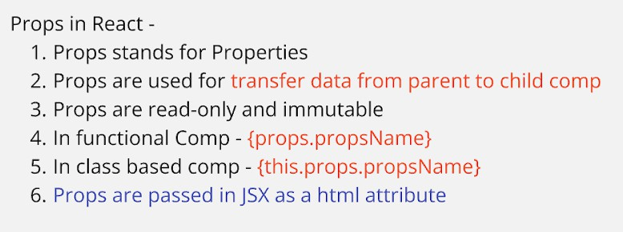**Props In React**

App.js

import './App.css';

import ChildA from './childcomp/ChildA' import ChildB from './childcomp/ChildB' import ChildC from './childcomp/ChildC'

function App() { const employee = {

id : 101,

name : 'Rakesh', city : 'Pune', contact : 7744556633

}

return (

<div className="App">

<h1>Props in React</h1>

<ChildA name='Virat Kohli' age='36'/>

<ChildB devName='Jordan Walke' appName='React'/>

<ChildC emp={employee}/>

</div>

);

}

export default App;

ChildA.js

const ChildA = (props) =>{ return(

<>

<h2>I am ChildA Comp</h2>

<h3>Player Name - {props.name}</h3>

<h3>Player Age - {props.age}</h3>

</>

)

}

export default ChildA

ChildB.js

import { Component } from "react";

class ChildB extends Component{ render(){

return(

<>

<h2>I am ChildB Comp - class</h2>

<h3>Dev Name - {this.props.devName}</h3>

<h3>App Name - {this.props.appName}</h3>

</>

)

}

}

export default ChildB

ChildC.js

function ChildC (props) { return(

<>

<h2>I am ChildC comp</h2>

<h3>

{props.emp.id} - {props.emp.name} - {props.emp.city} -

{props.emp.contact}

</h3>

</>

)

}

export default ChildC

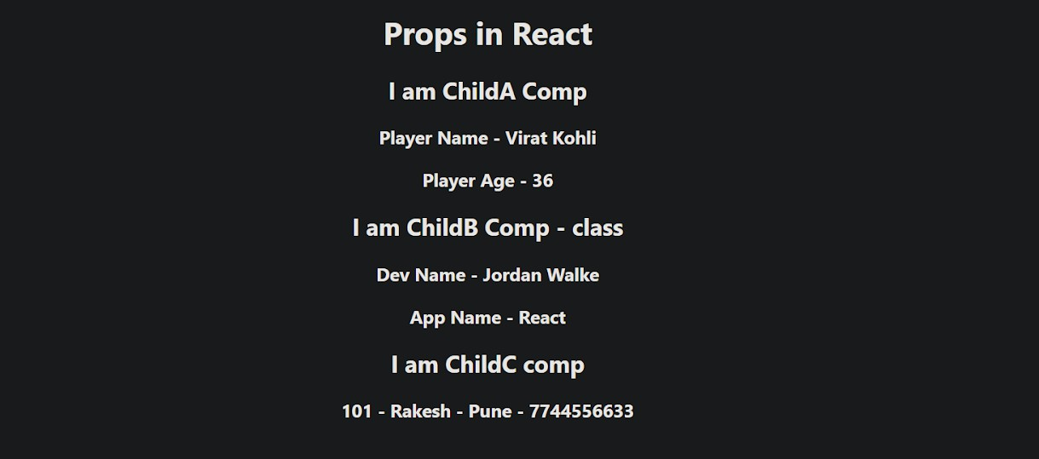

Props Drilling



**App.js**

import './App.css';

import ChildA from './childComp/ChildA' function App() {

return (

<div className="App">

<h1>Props Drilling In React</h1>

<h2>Parent Comp - App.js</h2>

<ChildA msg='Welcome to React' />

</div>

);

}

export default App;

**ChildA.js**

import ChildB from './ChildB' const ChildA = (props) =>{

return(

<>

<h2>I am ChildA Comp</h2>

<p>Msg - {props.msg}</p>

<ChildB A={props.msg}/>

</>

)

}

export default ChildA

**ChildB.js**

import ChildC from './ChildC' const ChildB = (props) =>{

return(

<>

<h2>I am ChildB Comp</h2>

<p>Msg - {props.A}</p>

<ChildC B={props.A}/>

</>

)

}

export default ChildB

**ChildC.js**

import ChildD from './ChildD' const ChildC = (props) =>{

return(

<>

<h2>I am ChildC Comp</h2>

<p>Msg - {props.B}</p>

<ChildD C={props.B}/>

</>

)

}

export default ChildC

**ChildD.js**

const ChildD = (props) =>{ return(

<>

<h2>I am ChildD Comp</h2>

<h3>Msg - {props.C}</h3>

</>

)

}

export default ChildD

